MINISTERIAL CANDIDATE’S FILE
Content checklist

Name ________________________________________________________________________
Address ______________________________________________________________________
Telephone (home) ________________ (cell) ________________ (work) _________________
E-mail ____________________________________ Date File Begun _______________

Please check the items below as they are place in the candidate’s file and the date item was added.
_____ Biographical Information Form * Date ____________
_____ Journey to Ministry in the AME Church Form * Date ____________
_____ Notarized Candidate Disclosure Form * Date ____________
_____ Letter of Recommendation from the Pastor * Date ____________
_____ Christian Experience Essay * Date ____________
_____ Background Check Report * Date ____________
_____ Psychological Evaluation Result Date ____________
_____ District Recommendation to the Board of Examiners Date ____________
_____ Academic Progress Document(s) * Date ____________
(Copies of degrees, Official Transcripts, Letter of Admission, etc.)
_____ Certified Copy of Birth Certificate * Date ____________
_____ Copies of all ministerial orders (if any) * Date ____________
_____ Copies of licenses (preaching and professional, if any) * Date ____________

Items marked with an asterisk (*) is to be obtained by the candidate’s pastor prior to submission to the District Conference.

AFRICAN METHODIST EPISCOPAL CHURCH
BIOGRAPHICAL INFORMATION FORM

Name ___________________________________________________ Date ____________________________

Address ____________________________________________________________________________________
Street City State Zip

Home Phone (_____) ________________ Mobile (_____) ________________ Birth date _________________

Sex: M ______ F ______ E-mail _____________________________________________________________

Ethnic Origin: Asian _____ African American/Black _____ Hispanic _____ Other:
Native American _____ Pacific Islander _____ White _____ _______________

Local Church _____________________________________________ City/State _________________________

Conference _________________________________________ District _________________________________

Briefly describe your involvement in your local church, such as your leadership positions, groups you enjoy, church activities, etc.

___________________________________________________________________________________________

___________________________________________________________________________________________

Describe your church involvement in activities beyond your local church, such as district or annual conference work, church camps, workshops, outreach, etc.

___________________________________________________________________________________________

___________________________________________________________________________________________

Your Educational Background Dates Attended Degree or Credit Hours

High School __________________________________ ________________ ___________________

College __________________________________ ________________ ___________________

Graduate School __________________________________ ________________ ___________________

Theological School _______________________________ ________________ ___________________

Course of Study for Ordained Ministry Yr. 1_____ Yr.2 _____ Yr. 3 _____ Yr. 4 _____ Yr. 5 _____

Advanced Course of Study: ______________________________________ Semester Hours Credit. _________

Marital Status: Single, never married ____ Married, in first marriage ____ Married, in second or more ____
Widowed ____ Separated ____ Divorced ____

If married, spouse's name __________________________________________ Birth date __________________

Date of Marriage _______________________________ Spouse's occupation ____________________________

Your Children, if any:
Name of Child Date of Birth Sex Education

_____________________________ ________________ ____________ _________________________

_____________________________ ________________ ____________ _________________________

_____________________________ ________________ ____________ _________________________

_____________________________ ________________ ____________ _________________________

_____________________________ ________________ ____________ _________________________

_____________________________ ________________ ____________ _________________________

_____________________________ ________________ ____________ _________________________

_____________________________ ________________ ____________ _________________________

ADDITIONAL INFORMATION
Share any additional information you need for us to know about you that will help you

___________________________________________________________________________________________

___________________________________________________________________________________________

___________________________________________________________________________________________

___________________________________________________________________________________________

___________________________________________________________________________________________

___________________________________________________________________________________________

___________________________________________________________________________________________

___________________________________________________________________________________________

___________________________________________________________________________________________

BEGINNING THE JOURNEY TO MINISTRY IN THE AME CHURCH
Congratulations Candidate on answering God’s call! As a candidate for ministry in the AME Church, use what you understand about your calling to help us identify the path of ministry God has called you to:
________ | ITINERANT TRACK | - Agree to travel regardless of where assigned  - Path to Deacon’s and Elder’s Ordination  - Amenable to the Quarterly, District and Annual Conferences  - Admission to the Annual Conference Board of Examiners  - Psychological evaluation and annual background checks required  - Education path to Master of Divinity degree from an accredited school required  - Leads to pastoral assignments
________ | LOCAL TRACK | - Desire to serve the local church  - Path to Deacon’s and Elder’s Ordination  - Amenable to the Quarterly, District and Annual Conferences  - Admission to the Annual Conference Board of Examiners  - Psychological evaluation and annual background checks required  - Education path to Associate degree from an accredited school required  - May lead to pastoral assignments
________ | EVANGELIST | - Licensed, renewed annually  - Amenable to the Quarterly, District and Annual Conferences  - Admission to the Annual Conference Board of Examiners  - Annual background checks required  - Education path to Associate degree from an accredited school required
________ | EXHORTER | - Licensed, renewed annually  - Amenable to the Quarterly Conference  - Supervised by the Presiding Elder District  - Annual background checks required  - High school diploma required
________ | LAY PREACHER | - Licensed, renewed annually  - Amenable to the Quarterly Conference  - Supervised by the Presiding Elder District  - Annual background checks required  - High school diploma required

I believe God is calling me to serve the church in the ministry checked above.

Candidate: _______________________________________ Date: ___________________________

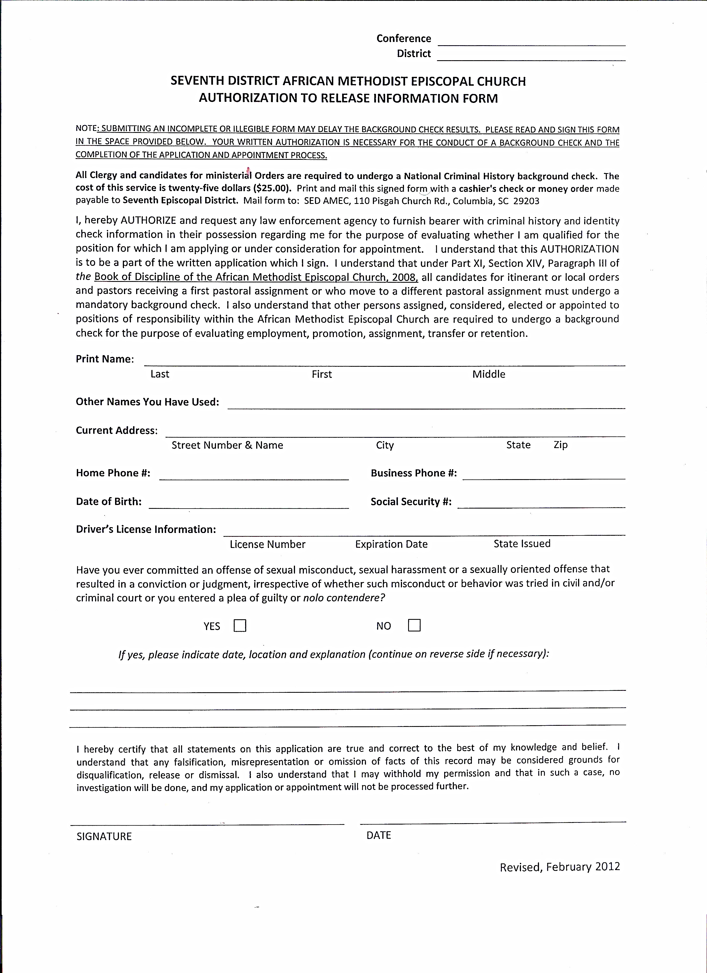

CANDIDATE’S CHRISTIAN EXPERIENCE ESSAY
Instructions
Candidates coming forward to offer themselves for service are asked to submit a 3 – 5 paged essay of their Christian experience (no more than 5 pages). The paper must address the following:
- Briefly share your current occupation/vocation and family structure (marital status, children, parents, relatives that are in ministry, etc.).
- Explain God’s plan for salvation using Scripture references.
- Explain the circumstances of your conversion (when you came to Christ for salvation).
- What is your devotional practice of study and prayer (both personally and in your local church)?
- Describe your call to ministry.
- In what roles do you serve in your local church? Please share the gifts used in your ministry to the church.
- What are your plans to prepare yourself for the ministry God has called you to?
- Why should the AME Church embrace you as a candidate for ministry?
The essay should be typed-written with Times New Roman, 12 point font, double-spaced with one inch margins on 8 ½ by 11 inch paper. The standard for this paper is consistent with most seminary standards that require a Christian Experience Essay as part of the application process.
The essay should be forwarded to the registrar of the District Board of Ministerial Orders on the designated date prior to the District Conference. Send or e-mail the essay to:
Rev. Lester J. Drayton, Jr.
Registrar – District Board of Ministerial Orders
414 Riverwalk Way
Irmo, SC 29063
E-mail: pastor@gspamec.org

A copy of the essay should also be maintained in the candidate’s file.

THE AFRICAN METHODIST EPISCOPAL CHURCH
CANDIDATE’S DISCLOSURE FORM

Please complete this form, sign and date it, have your signature notarized, and return it to
Rev. Lester J. Drayton, Jr.
Registrar – District Board of Ministerial Orders
414 Riverwalk Way
Irmo, SC 29063

Have you ever been:
- convicted of a felony? _____ No _____ Yes
- convicted of a misdemeanor? _____ No _____ Yes
- accused in writing of sexual misconduct or child abuse? _____ No _____ Yes
If you answered yes to any of these questions, please explain.
___________________________________________________________________________
___________________________________________________________________________
___________________________________________________________________________
If you are required by this disclosure form to disclose any written accusation or conviction for a felony, misdemeanor or any incident of sexual misconduct that you dispute or believe should be explained in any way, you have the opportunity to include any additional information you believe might be helpful or important regarding the disclosure.
Any additional and relevant information should be provided in a response statement attached to this form. (Note: it would be preferable to include your response statement on the disclosure statement. However, you may use additional paper to write your response statement and include it with this form. Please indicate if additional pages are attached.)
I hereby certify that the information provided on this form is true and accurate.
Print Name ________________________________________________________
Signature _________________________________ Date ____________________

JURAT STATEMENT
Sworn and Subscribed before me on this ____ day of ________________, ________
_________________________________________________
Notary Public for South Carolina
Commission Expires: ________________________________

